
A.L.L.
Newsletter from the Association for Light and Life

Spring 2005
****************************************************************************************

In this issue:
- Transitioning Officers
- Reminiscing
- Common Ground
- Caribbean Tour
- Annual Registration/Fundraiser
- Events, Project Notes & More…
The security of a religious group depends on spiritual unity, not on theological uniformity… There is great hope for any (group) that worships the living God, validates the brotherhood of man, and dares to remove all creedal pressure from its members.
– Urantia Paper 103, Section 6

____________________________________________________________________

Welcome to the Newsletter of the Association for Light and Life. Winter has come and gone and we find ourselves on the verge of Spring with fields to till, seeds to plant, things to do and places to go. There is much happening, with gatherings on the horizon, service projects in the works, our annual membership drive getting underway, and time for a recap of our eventful first year. But we have no intention of stopping there and resting on the good works of yesteryear. It’s time to go another mile and take advantage of the groundwork that’s been laid to move into new service opportunities. But first, take a break, find a good seat, kick up your heels and enjoy the read!

Transitions
From Bob Devine:
In December, I made the personal decision to step down as Presiding Officer of ALL after my term was concluded. Although it has been a very rewarding experience, I wanted to spend more quality time with my family and I have other service efforts I want to spend time on that have been sitting on the back burner. I will remain on the Coordinating Council of ALL, but am quite happy to turn over the position of Presiding Officer to my friend, Allene Vick, who is also on the Coordinating Council. After Allene made it known that she was willing to be considered for the role, the Council voted unanimously to accept her as our new Presiding Officer. Allene has been involved with ALL from the outset, and has a history of service, as well as a background in business. We have full confidence that she will bring enthusiasm, a listening ear, and a dynamic nature to the role. Please join us in welcoming Allene, as ALL moves forward in our efforts to be of service in 2005.

From Allene Vick:
Dear Members, it is with great pleasure that I am writing to you as the Presiding Officer of ALL. I would like to express my extreme thanks to Bob Devine for his efforts in bringing the idea of ALL into reality and the magnificent job he has done as Presiding Officer the first year to bring ALL to what it is today and the many accomplishments of the first year, which are described in this newsletter. I am sure you all join me in saying THANK YOU BOB!!!
Bob is truly a hard act to follow, but I will put forth my best efforts. As I mentioned to the council, the first couple of months I will be somewhat passive in my role as presiding officer, but as my schedule changes and I have more personal time, I plan to be very active in the affairs of ALL. I hope that you all will feel free to call me any time you have something you would like to discuss. My phone number is 703-435-4342. You can call me anytime after 10:00 a.m. EST. I have a set monthly phone charge, so I can call you back. If I start talking to you and forget, please interrupt me and remind me to call you back.
I believe that ALL has unlimited opportunities to be of service and I look forward to working with all of you to see these opportunities blossom into realities.

With love and appreciation for you all,
Allene Vick, Presiding Officer
Reminiscing

As we look forward to 2005 and all that it brings, we take a moment to look back at our past year so we can see the progression of our efforts toward building light and life one step at a time, individually, collectively, and universally.

2004 was an exciting and productive year for ALL. Starting with about 20 members at the outset, we now have nearly 75 Active Members and another 25-30 Associates who have registered, mostly at our community website. Our belief is that communication and networking are critical steps toward providing long-lasting service and a sense of community. As ALL members reach out in service, it is our communications network that will keep newly inspired people in touch with what’s going on so they can find ways to become part of the effort, and some may just want to feel that connection with others of like mind as they go about their business in their own community.

To build a communications network, the team of Russ Gustafson, Thea Hardy, Delores Pollard and Bob Devine have developed three websites: our main ALL site www.associationforlightandlife.org (also accessed via www.lightandlife.us) which puts us into the internet world; the community website at http://all.lightandlife.us with discussion boards, email lists, and resources for associates to utilize; and we have the SpiritWorks Store at www.allspiritworks.com to sell the creative works of artists in our communities. The ALL Newsletter is another level of communication to keep in touch with our associates and to inform people about the activities and plans of ALL, especially those who don’t have computer access. We have also developed Spirit Magazine, which is a periodic outreach publication of spiritual and philosophic insight from many sources that is designed to go on college campuses, and be placed in bookstores, coffee shops, etc. These communication tools are to reach out to the world, as well as to keep people in contact with one another and with what’s going on.

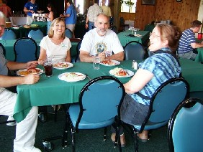
Conferences and gatherings are a great way for people to connect, talk about ideas, and share in spiritual fellowship with one another. 116 people found their way to the Conference on Spiritual Unity in Boise, Idaho last summer, where we enjoyed unity of spirit without uniformity of beliefs. It was exciting to see people from the Fellowship, Foundation, IUA, TeaM, ACIM, and more, all come together and enjoy a weekend with each other, to hear different perspectives, to talk about hopes and dreams, listen to good music, and perhaps forge ways to work for common goals, letting our differences take a back seat to the siblinghood we all have in common. We look forward to a similar and growing experience in 2006 with our conference in Santa Barbara, California. We also supported the Albuquerque, New Mexico, Retreat here just a couple of weeks ago, and look forward to making other gatherings possible in the future.

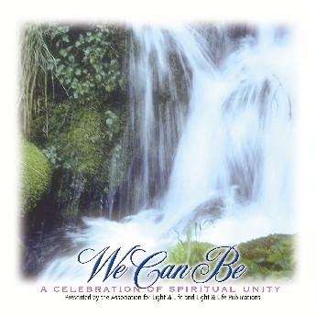
ALL is building an emphasis on supporting projects that align with our purposes. In 2004, we were happy to aid with many things, including helping to create We Can Be: A Celebration of Spiritual Unity, a compilation CD of Urantia musicians, which is now sold at www.allspiritworks.com. This CD was put together by Jim Cleveland and Mark Austin who worked with ALL in gathering musical contributions from 16 different artists from all walks of the movement. To list other projects, with Mark Greer’s initiation and a little fundraising, ALL was able to pay travel expenses for several young adults to go from the Chicago IUA conference to the young readers retreat at Silver Springs, Ontario, as well as to help sponsor youth at Boise. This November and December, ALL was able to help Norman Ingram coordinate resources to enable several Urantia Books to be delivered to Peru in time for Christmas. ALL has also helped in raising funds for the maintenance and design of TMArchives at www.tmarchives.com. On the publishing side, Mary Ebben Livingston’s Urantia Book Basics has been adapted into a digital e-book download, thanks to the efforts of Gerdean Bowen who helped Mary in editing the book, which is available now at www.allspiritworks.com. And ALL was particularly glad to be able to work with members of the Retreat Network at the Boise Conference, having them facilitate the pre-conference retreat for a group of 40+ people. And the list goes on.

Starting from scratch little more than a year ago, it is heartening to see the diversity of efforts and the success that comes from stepping forward in service. After stopping to take a look over our shoulder, we look ahead to 2005 wondering what this year will bring. By all signs it looks to be another interesting, exciting, and service-filled year.
On the Horizon

Santa Barbara, CA Retreat -- April 1-3, 2005
Coming up soon. Register now!!! The Retreat Network invites you to their retreat at La Casa Maria Retreat House in Santa Barbara, CA (www.lacasademaria.org.) This retreat will explore the theme, "THE LIFE TO WHICH WE HAVE BEEN CALLED". There will be readings from the Urantia Book, centering prayer, music, quiet reflection time and the retreat will end with group worship.
COST: $250. (Includes 2 nights lodging, 6 meals and retreat program and materials) Partial scholarships are available. A deposit of $100 is due by March 15, 2005. To access registration form, go to http://all.lightandlife.us/Events/9802.aspx. For more information contact Dolores Nice at dlnice@worldnet.att.net.

Common Ground Outreach Festival – July 6-11, 2005

COMMON GROUND is an outreach group, consisting of Barbara Hester, Bob Devine, Rick Giles, Dolores Nice, Mark Turnbull, Mark Austin, Richard Knox, Donna D’Ingillo, Judy Langston and Mark Greer, who have committed to come together to do a weekend music/spirit/peace festival for the public in the Spokane, Washington/Coeur D’Alene, Idaho area this summer. Having the atmosphere of a festival, we will have musical performances, speakers, poets, workshops, skits, and multi-media efforts that emphasize the concepts we have learned and ideas we believe all people should hold in common – a personal relationship with God and our common relationship as brothers and sisters in the spiritual family of God. Developing personal spiritual experience through stillness, worship and service, and joining in community through discussion, sharing and song will be the particular emphasis.

Mark and Mary Rogers have agreed to host the group at their home outside of Coeur D’Alene, and several other people in the area, including Tom Newbill, Ginny Jakubiak, and Harold Holloway, have volunteered to participate, as well. This effort is a prototype effort to gauge the feasibility of doing a more concerted outreach in multiple cities in the future.

ALL has kicked in to help Common Ground with some support and the group is hoping to raise enough money for site rentals and to advertise in local magazines, newspapers, and on radio. If you are interested in contributing to the effort to make this happen you can contribute at www.lightandlife.us under the donations link or send a contribution to ALL, c/o Common Ground, 8600 N. Maple Grove Ln, Pocatello, ID 83201. Any support will be greatly appreciated. For more information contact Bob at bobdevine@onewest.net.

Caribbean/Cuban Tour
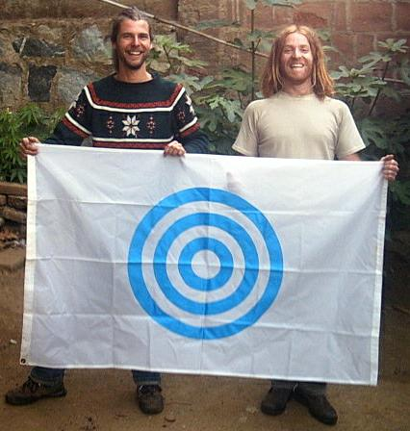
This summer, Urantia Nations Outreach is sponsoring an effort by Pradhana Fuchs and his friend Coloro to get Urantia Books placed in Cuba and to connect with the few readers there. The original vision has been expanded to include neighboring countries, such as Puerto Rico, but we include the original letter from Pradhana here in the hopes that those who might be interested can help support this worthy cause of getting Urantia Books placed throughout the Caribbean. At the time of this newsletter, UNO has received about two-thirds of the funds necessary to carry out the project and ALL has committed funds to help make this happen.
***********************************************************
Brothers and Sisters of our Urantia Community,
Warm greetings from Chile. My name is Pradhana and my friend Coloro and I are writing to you because our souls are hungry to establish an effective Urantia Book Outreach in Cuba. We are willing to gives our lives to this mission but we need help with the cost of Spanish Books, travel and minimal living expenses.
For some time we have been in touch with a reader group in Havana that probably have the only five books in all Cuba. Most of you know the history of this special island country and the plight of the Cuban people. Our work is not political so we won't give opinions, but we are very concerned that Cuba does not have the same possibilities to receive new spiritual meanings as many other countries have. We want to bring books to Cuba and spread our new revelation in
this amazing country. We know that the people in Cuba are waiting for these new seeds. As lovers of the Urantia Book, we know what kind of seeds are in our little blue treasure. We want these seeds to sprout and we feel called to be the sowers.
Our plan is to visit and place books in each of the 14 districts that comprise Cuba. We intend to share with the people, one-person-at-time, our love of the teachings and to complete the mission by July so that we can share our experiences at the International Conference of 2005 in Philadelphia. Your financial contribution will help spark our plan into action and move it ahead in a divine direction. We thank all the ones that have helped us throughout all these years plus UNO (Urantia Nations Outreach.)
Contributions will be gratefully accepted by the nonprofit Association for Light and Life for this project, who is working with Urantia Nations Outreach to make this happen.
Please make check out to and send contributions to:
Association for Light and Life
Attn: UNO
8600 N. Maple Grove Ln.
Pocatello, ID 83201
You may also contribute at www.lightandlife.us under the Donations link and put in the memo space that it is for UNO.
Thank you & Thanks to God,
Pradhana Fuchs
----------------------------------------------------------
WHAT IS Urantia Nations Outreach (UNO)?
Our mission is to reach Urantia nations and donate books to the national libraries, university libraries and main prison libraries of most of the planet. The founder and contact of this beautiful group is Norman Ingram from the energy operation center in Los Angeles. Norman found me traveling in South America and introduced me to The Urantia Book. I was told in a dream to travel north and the next day met Norman. Seed CUBA is the newest project.
To communicate with Norman and UNO more about this project, contact:
Ph/Fax: 562 698 2122
E-mail: norlastar@aol.com
Web site: http://www.ubla.org/uno (Go here for UNO stories)

Urantia IC’05, near Philadelphia, PA – July 31-Aug 4, 2005

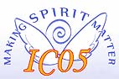
The Urantia Book Fellowship’s International Conference is slated to be held at Villanova University near Philadelphia from July 30 through August 4, 2005. The year 2005 is the 50th anniversary of the publication of The Urantia Book, and so the title of the conference is “MAKING SPIRIT MATTER: The Next 50 Years”. The conference is intended to celebrate this significant anniversary as we look forward to the next fifty years of growth. For more information and registration forms, go to www.urantiabook.org and click on the “Making Spirit Matter” icon. It is shaping up to be a wonderful event as Urantia Book readers gather from around the world to study, discuss, worship, play and rejoice in the spirit. Don’t miss it!

Conference at Sea – August 4-8, 2005
Celebrating the 50th Anniversary of the URANTIA Foundation's printing of the original URANTIA Book. The theme is “Science, Philosophy, and Spirituality.”

Hawaii Urantia Local Association on behalf of the URANTIA Association of the United States invites you to a conference at sea in August 2005. The beautiful Carnival Sensation will set sail for Cozumel, Mexico, from New Orleans on the afternoon of August 4th, returning to port on August 8th. Cabin capacity is almost unlimited. For more information and to register, go to http://www.urantia-iua.org/events.html#uaus.

July, 2006 – ALL Unity Conference – Santa Barbara, CA.
Details to come later.
SpiritWorks Store News
(www.allspiritworks.com)

SpiritWorks now has the Urantia Book for sale (not to mention all the other creative items spoken of in this newsletter). The Fellowship’s Edition from Uversa Press runs $14 and the Foundation’s edition has been running $13, although we only have 9 left at that price. (The Foundation’s wholesale price is going up, so once those 9 books are sold, we will be raising the price.) Both are currently at the lowest retail prices we’ve found on the internet.

SpiritWorks’ primary purpose is to make spiritually related works from authors, musicians, and artists available to the public at the lowest prices possible. We work as an agent for independent artists to get their products available to a wider audience. Please take some time to peruse SpiritWorks today at www.allspiritworks.com. Listen to samples of the musical artists while reading about albums, books, or viewing artwork. If you are an artist and would like your work at the store, please contact us at spiritworks@onewest.net for details.

Project Notes:
The Revelation Takes the Classroom Road:
The Personal Creed Project and a New Vision of Learning
Author and school teacher John Creger has developed a two-part workshop stemming from his recent book on the Personal Creed Project. Participants weave self-discovery through this interactive session, creating personal creeds while exploring Creger's nationally-recognized model of learning synthesized from The Urantia Book. In Part II, participants share the results of their creed reflections in mini-presentations and go on to consider how the Creed experience stands to equip students and teachers to re-invigorate the spiritual roots of American democracy. Experience this workshop at the Urantia IC’05 in Philadelphia this summer and/or consider inviting John to do a presentation in your area. Half day and full day interactive seminars are available. Contact John at jcreger@jps.net for more details and booking.

“Soul Stories” in Production:
Jim Cleveland and Mark Austin have just completed recording “Soul Stories,” the third CD in a series of four that combines poetry, music and song. This CD will soon be available along with “Souls Pouring” and “Souls Blooming” which are available now at www.allspiritworks.com or at www.cdbaby.com/all/lightandlife.

Publishing World Religions Quotes:
Marty Greenhut writes: “Dear ALL, We have been hoping to hear from a volunteer who can type and format a book of quotes from the religions of the world that were assembled by Al Wolf. Jim Young has selected a bunch of these quotes that will make a very nice little book. Love, Marty.” These quotes that Marty refers to are in an archive at the ALL website, www.lightandlife.us, under the Spiritual Resources link. If any are interested in helping to work on this, please contact Marty at martyg@bcn.net.

Jesus in Red
Have you ever wanted to read just what Jesus had to say in the bible without all the other commentary? Bob Devine is working on The Red Parts Bible: The Teachings of Jesus from the New Testament. The book will consist of all of Jesus’ commentary in the bible with only enough description to provide context for his words. Bob hopes to have this book up on the ALL site as a download sometime in the next few months.

Light and Life Publishing
Jim Cleveland has published four Urantia/TeaM based books which can be found at: www.authorhouse.com and www.LightandLife.com is now partnering with a new webmaster to overhaul, streamline and expand the site. Two issues of the Light and Life Journal are in waiting and Jim is anticipating and planning a regular flow of news, features, periodicals, books and music via Light and Life Publishing at www.lightandlife.com. Please send any and all creative submissions for the Journal or specific sections of the website to Jim at jimcleveland@tds.net. All L&L space is free, so send information on your books, CDs, etc., and send narratives for the Journal.

Remembering New Mexico
by Gerdean Bowen

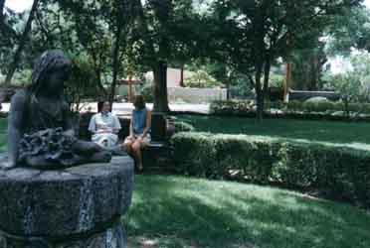
The Southwest Teaching Mission Retreat & Reunion has come and gone but not without leaving a lasting impression on all who attended. The success of the Retreat was due, in large measure, to the inherent ambiance of the Canossian Spirituality Center itself. The planners wanted to create an event that provided time to do all the things we would do at a conference if we weren’t at a speech or workshop, so structure for the Retreat was minimal. After Wayawahili’s opening prayer Friday evening, coordinator Gerdean Bowen told the group, "You’re on your own!" It didn’t take long for Spirit to completely prevail.

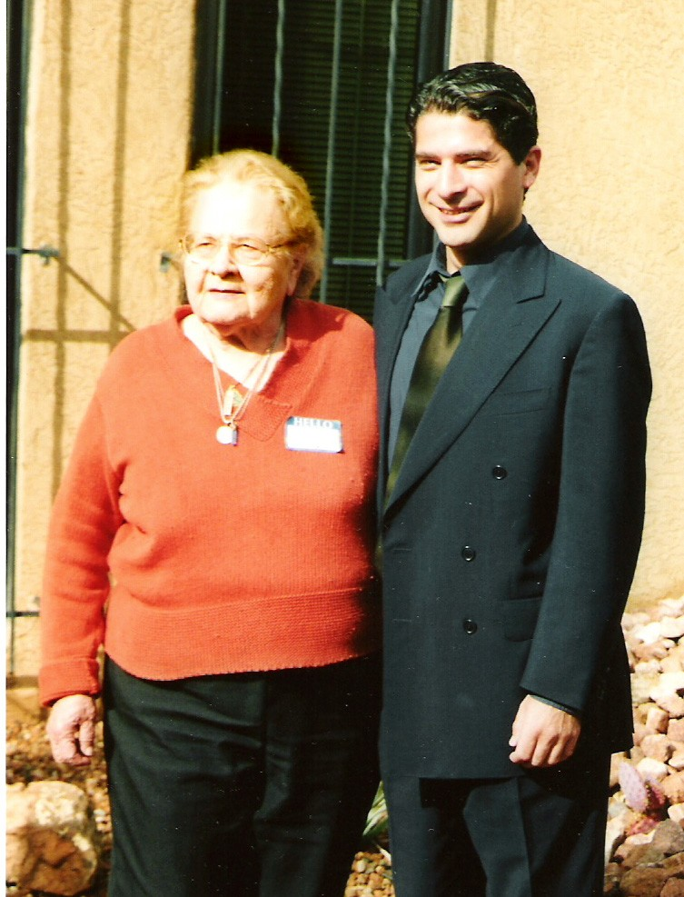
Saturday morning in the chapel, Daniel Raphael led us to hear messages from Teacher Rayson, Christ Michael and Machiventa; Jo Ann Weidman brought us a message from the Divine Minister. Rayson’s message continued in the library on Saturday afternoon, even as the healers set to work in the map room and across the hall in the conference room, an array of family "show and tell" service projects were kicked off by Stella Religa, author of "Secret Revelation.”

Gifted Santa Fe music man/producer, Dominique Morales (pictured here with Stella), had been composing his opus "Apocolypsis." Realizing that an important element was missing, he sought guidance in a bookstore where he espied Stella’s book. So impressed was he with the clarity of Apostle John’s testimony of the true nature of biblical Revelations, that Dominique devoured Stella’s book and went on to discover the Urantia Papers. He flew to California and met with Stella, who invited him to the SW TeaM R&R. There, Dominique told this story, embellished with many fascinating details of his youth, career, and aspirations. We were all spellbound, and eagerly await the presentation and the inevitable effects of this opus on Christianity.

Another compelling recitation came from Norman Ingram, who talked about the behind the scenes seraphic action that brought the Chilean Pradhana into his life, destined to take the Urantia Papers into Cuba. Dolores Nice talked about her experiences with Prison Ministry and with the Retreat Network. Gerdean entertained listeners with a reading from her novel, "The Zooid Mission." Joilin and Eric shared the incredible saga of Eric’s miracle recovery.

The featured Saturday evening entertainment was Dorenda Morse, who flawlessly played several classical piano selections (Beethoven’s "Pathetique", Bach, Debussy), interspersed with a recital from Carl Stafford (Wayawahili), and a message from "the Spirit of a Descending Son” luring us to service.

Sunday morning communion provided us one more opportunity to remember the blessings of Sonship. It was a wonderful experience of family and community, so much so that we hope to have another gathering in Albuquerque in the future.

“The mission in this world as it pertains to you is involved in the outreach of spiritual insight. The world has many participants from different nationalities and faiths, and though the frameworks this information comes through are somewhat different in appearances, the content of the messages are continually the same: the truth of the spirit of the Father within each person, and the increasing connection that people can make with this spirit. This is the most important single message that can be given to seekers of all religions today — the reality of the inner personal experience with God.” -- Teaching Mission

Now is the time for people to either renew or enroll as Active Members in ALL, which comes with voting privileges. Prior year Active Membership expires after the first quarter of each year, which is the end of March. As you read about the services that ALL has been able to provide in our first year, and as you see plans beginning to form for 2005, it is our hope that you will want to enroll or renew membership. Costs are associated with the operation of ALL, such as maintaining and developing websites, printing, mailing, phone expenses, and correspondence, such as newsletters.

So if you are a current member, please take the time to support the Association with a contribution for the current year and if you are interested in becoming a member, please fill out the form below and send it in. Anyone can be an Associate by simply filling out and returning the form, but to be an Active Member one must either contribute financially or sign a waiver outlining your proposed or actual service on some project related to ALL in the current year (feel free to propose your own project). We thank you for your support of ALL and look forward to offering more ways to be of service to you in the coming year.

(People can also register and contribute online by going to www.lightandlife.us under the Membership link.)

Membership and Contributions
****************************************************************************
Name(s)_________________________________________________________ Date___________________
Address_________________________________________________City_____________________________
State/Province___________________ Country_______________________ Zip/Postal Code______________
E-mail____________________________________ Phone (optional)_________________________________
In registering as a Member of the Association for Light and Life you can choose to be an Associate Member or an Active Member. Please choose one.

( ) An Associate Member is any person who supports the purposes of the Association for
Light and Life.
See the Purposes at www.associationforlightandlife.org/about/about.html. You may
also request a copy of the purposes by sending us a note at one of the addresses listed.

( ) An Active Member is an Associate who has either contributed financially to ALL during
the current calendar year, or in lieu of a financial contribution has volunteered time in
service toward an ALL sponsored project or activity and signed a waiver. Active Members
also gain the privilege of voting during elections or on any referendums.
(Note -- In lieu of setting membership dues for ALL, a tax deductible contribution is
suggested to maintain basic services, such as newsletters, directories, websites, printing and
mailing costs, etc. Rather than suggesting a set amount, each member should decide the
level of their contribution based on their own financial situation and inclinations.)

( ) Check here if you are making a contribution at this time. Amount ______

This form may be sent by Email to all@onewest.net, or you can send this form, as well as contributions, with checks made payable to the Association for Light and Life, to:

Association for Light and Life
c/o Treasurer
8600 N Maple Grove Ln
Pocatello, ID 83201

Contributions by credit/debit card can also be accepted at: www.lightandlife.us/donations/donations.html
Thank you for joining ALL!!!

Well, that wraps it up for this issue of the ALL Newsletter. Again, if you would like to join the ALL Network, you can do so at www.lightandlife.us under the Membership link or send us a note with your request, along with name, address, and either telephone, E-mail address, or both. Our address is: Association for Light and Life, 2582 E Hudlow Rd, Hayden, ID 83835. Our E-mail address is all@onewest.net.

Donations are not required to be an Associate of ALL. We welcome anyone who resonates with our purposes. With that said, Active Member status and voting privileges are granted to those Associates who have contributed financially to ALL or spent time in service on an ALL related project during the current year. Financial contributions can be made online at www.lightandlife.us or mailed to the address above. All support, in spirit, in service, financially, or otherwise, is greatly appreciated.

We’ll see you this Summer with another ALL Newsletter and we hope to see you in Santa Barbara, Philadelphia, Coeur D’Alene, cruising toward Mexico, or out on the streets in service. Peace, Love, and Light!!!

Association for Light & Life
2582 E Hudlow Rd
Hayden, ID 83835

